|  |  |  |  |
| --- | --- | --- | --- |
|  | **Advertising Monthly Report** | | |
|  | **As of 29th February 2024,** | |  |
|  |  | | |
|  |  |  |  |
|  |  |  |  |
|  |  |  |  |
|  |  |  |  |
|  |  |  |  |
|  |  |  |  |
|  |  |  |  |
|  |  |  |  |
|  |  |  |  |
|  |  |  |  |
|  |  |  |  |
|  |  |  |  |
|  |  |  |  |
|  |  |  |  |
|  |  |  |  |
|  |  |  |  |
|  |  |  |  |
|  |  |  |  |
|  |  |  |  |
|  |  |  |  |
|  |  |  | February, 2024 |
|  |  |  |  |
|  |  |  | Report |
|  |  |  |  |
|  |  |  | |
|  |  | |  |  |  | | --- | --- | --- | |  |  |  | |  |  | |  |  | | |

Kenbright Actuarial & Financial Services

www.kenbright.co.ke - Kenbright. Since 1993

DOCUMENT TRACKING

Revision History

|  |  |  |  |
| --- | --- | --- | --- |
| **Version** | **Author** | **Date** | **Revision** |
| 1.0 | Gacheru Wanjiru | February 2024 | Creation |
|  |  |  |  |
|  |  |  |  |

This Document Has Been Submitted To

|  |  |
| --- | --- |
| **Submitted to** | **Date Submitted** |
| Emerging Markets - Advertising | February 2024 |
|  |  |

OUR REF

\\https://kenbright.sharepoint.com/sites/innovation/SharedDocuments/General/Templates/Report/ReportTemplate.docx

DOCUMENT PURPOSE

This document has been produced to establish analysis for the Emerging Markets

To protect the confidential and proprietary information included in this document, it may not be disclosed or provided to any third parties (unless for statutory reporting) without the approval of the Data Scientists.

# Table of Contents

Table of Contents 3

List of Tables & Figures 4

1. EXECUTIVE SUMMARY 5

Instagram 5

Facebook: 5

LinkedIn: 5

Twitter: 5

2. DEFINITIONS 6

3. TWITTER (X) 7

4. INSTAGRAM 9

5. LINKEDIN 11

6. FACEBOOK 13

7. RECOMMENDATIONS 15

# List of Tables & Figures

Table 1: Key Performance Indicators (Twitter) 7

Table 2: Key Performance Indicators (Instagram) 9

Table 3: LinkedIn Insights – February 2024 11

Table 4: Facebook Insights – February 2024 13

# EXECUTIVE SUMMARY

* 1. The Executive Summary presents a concise overview of the significant findings resulting from the analysis of Kenbright's social media accounts. The report focuses on covering the period from **1st to 29th February 2024**.

### Instagram

* 1. **Increased Reach:** Instagram saw a **56.2%** increase in reach in February as compared to January, 2024.
  2. **Content Interactions:** Content interactions increased by **27.8%** reflecting a major increase in audience interaction.
  3. **Increased New Followers:** There was a **major** increase in new followers with a surge of 61 new followers.
  4. **Increase in Impressions**: Impressions substantially increased by **268%**.
  5. **Profile Visits:** Profile visits increased by **335%.**

### Facebook:

* 1. **Increased Reach:** Facebook saw a major increase in reach by **73.7%** to 2.4k in February compared to that of January.
  2. **Engagement Continues:** Engagement was as well relatively high with an average rise of **72.6%** post engagements.
  3. **New Page Likes:** The page recorded **1** new page likes.
  4. **New Followers Increase:** Our Facebook following continued to expand with **20** new followers in February.
  5. **Reactions Consistency:** We recorded a total of 81 reactions, showcasing an average consistent audience engagement.

### LinkedIn:

* 1. **Growth in Unique Visitors:** There was a notable **100.4%** increase in unique visitors.
  2. **Custom Button Clicks:** Custom button clicks surged by **33.3%** indicating heightened audience interaction.
  3. **New Followers Growth:** New followers grew by **35.3%.**
  4. **Impressions Surge:** We recorded a surge in impression amounting to **22,587k** impressions**.**
  5. **Increased Content Reactions:** Content reactions saw a significant **94.8%** increase.
  6. **Reposts:** Reposts increased by **80%.**
  7. **Comments Spike:** Comments spiked by a remarkable **333.3**%.

### Twitter:

* 1. **Impressions Increase:** Impressions on Twitter saw a major increase to **1.5k** impressions from **1.1k** in January.
  2. **Steady Retweets:** Our Twitter retweets slightly increased from 17 to 18 in the month of February.
  3. **Drop in likes:** We recorded a drop in likes from 135 to **88.**
  4. **Rise in Engagement Rate:** We recorded a **7.6%** engagement rate, which is a slight drop from January’s 7.8%.

# DEFINITIONS

* 1. **Impressions:** Impressions refer to the total number of times a post, advertisement, or content is displayed on users' screens, regardless of whether they interact with it or not. It represents the potential audience size that has been exposed to the content.
  2. **Engagement:** Engagement measures the level of interaction and activity that users have with a post or content. It includes actions such as likes, comments, shares, retweets, and other forms of interaction that indicate user interest and involvement.
  3. **Reach:** Reach represents the total number of unique users or accounts that have seen a particular post, advertisement, or content. It indicates the size of the actual audience reached by the content.
  4. **Following:** Following refers to the number of users who have subscribed or opted to receive updates from a particular social media account, such as followers on Twitter, Instagram and LinkedIn, fans on Facebook, or subscribers on YouTube.
  5. **Profile Visits:** Profile visits count the number of times users have visited a social media profile or account. It shows the level of interest users have in exploring more about a specific account or individual.
  6. **Profile Interaction:** shows how active the fans engage with posts of a page. It shows the average amount of all interactions (reactions (likes, love, wow, haha etc.), comments and shares) per fan per post.
  7. **Profile Activity:** Profile activity breaks down the actions users take after visiting your profile. You can see the number of website taps, business address taps, call button taps, email button taps, and text button taps. For these metrics to show up, however, you have to have set up those buttons.
  8. **Link Clicks:** Link clicks track the number of times users have clicked on a link included in a post or content. It measures the effectiveness of a call-to-action, or the interest generated by the shared content.
  9. **Mentions:** Instances where a social media user includes the username or handle of another user or brand in their post or comment.
  10. **Engagement Median:** The average level of user interaction with content, calculated by finding the middle value of likes, comments, shares, and other engagement metrics. It represents the typical or typical level of engagement.
  11. **Click-Through Rate** **(CTR)**: CTR is a metric commonly used in digital marketing and online advertising to measure the effectiveness of a specific advertisement, link, or call-to-action in encouraging users to click on it and take the desired action.

# TWITTER (X)

* 1. The table below shows how our twitter account performed with regards to impressions, engagement, following and reach among other indicators. The terms have been defined under **Section** 2: Definitions.

Table 1: Key Performance Indicators (Twitter)

|  |  |
| --- | --- |
| TWITTER   FEBRUARY 2024 | |
| **KPI** | **Total** |
| Impressions | 1468 |
| Engagement Rate | 7.6% |
| Retweets | 18 |
| Likes | 88 |
| Replies | 2 |

* 1. **Total Impressions:** The total impressions on Twitter saw a slight increase to 1,468. This suggests a positive content uptake on Twitter.
  2. **Engagement Rate Increase:** The engagement rate slightly dropped to 7.6% compared to 7.8% in January.
  3. **Retweets:** The number of retweets reached 18, demonstrating that the content was shared by users who found it valuable or interesting. This indicates an active and engaged audience.
  4. **Likes (Favorites):** There was a drop in likes, with a total of 88 likes on the content. This suggests that most of the content might not have been resonating with the audience adequately.
  5. In summary, Twitter performance in January was average and calls for better content strategies and optimization.
  6. Below is a screenshot of the top performing tweet during the reporting period.

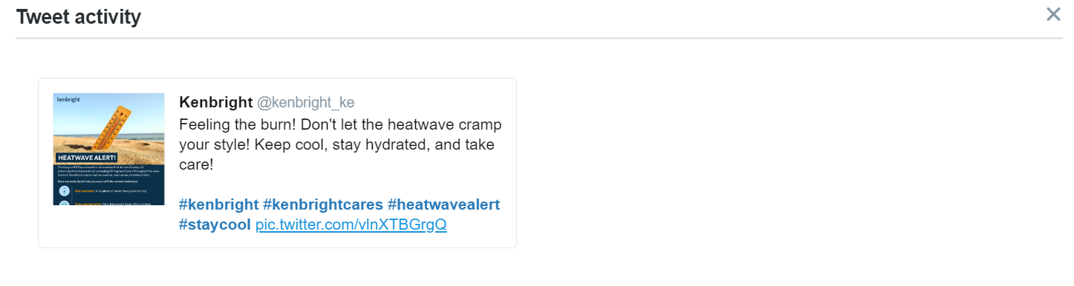

Figure 1: Top performing tweets and month summary (February 2024)

* 1. Notably, the most successful Twitter post was the heat advisory post that was intended to encourage our clients and the general public to keep safe and hydrate amidst the high temperature levels predicted by MET Kenya.

# INSTAGRAM

* 1. The table below shows the company’s performance on Instagram in the month of February.

Table 2: Key Performance Indicators (Instagram)

|  |  |  |
| --- | --- | --- |
| INSTAGRAM  FEBRUARY 2024 | | |
| **KPI** | **Total** | **Percentage** |
| Reach | 222 | +56.2% |
| Content Interactions | 257 | +27.8% |
| Followers | 61 | +4% |
| Impressions | 9563 | +268% |
| Likes, saves and shares(Profile Activity) | 434 | +347% |
| Profile visits | 418 | +335% |

* 1. **Reach:** There was a surge in reach in the month of January recording an increase of 56.2% to a total of 222. This show our content on IG resonated with a bigger audience.
  2. **Content Interactions:** Our content interactions increase with 27.8% to a total of 221.
  3. **Followers:** Our following on Instagram increased slightly by 4% to 1879.
  4. **Impressions:** There was quite a slight drop in impressions by -18.9% to 3563 impressions in February.
  5. **Likes, Saves and Shares:** There was a slight increase in likes, shares and saves by 347% recording 418 interaction in profile activity.
  6. **Profile Visits:** Profile visits substantially increased by 335%, indicating that more users were exploring the Instagram profile during this period as compared to January 2024.
  7. Relatively, the performance of our Instagram page was great. This can be attributed by the fact that there was a lot of activities in the month of February,
* Influencer Marketing - Our partnership with MPESA saw us have an in influencer promote our product (Vehicle) on MPESA app.
* Social Media Marketing – We promoted the 1K One Month Third Party Only Cover that saw us onboard close to 15 new client in that month.
  1. The image below shows our top performing post on Instagram.

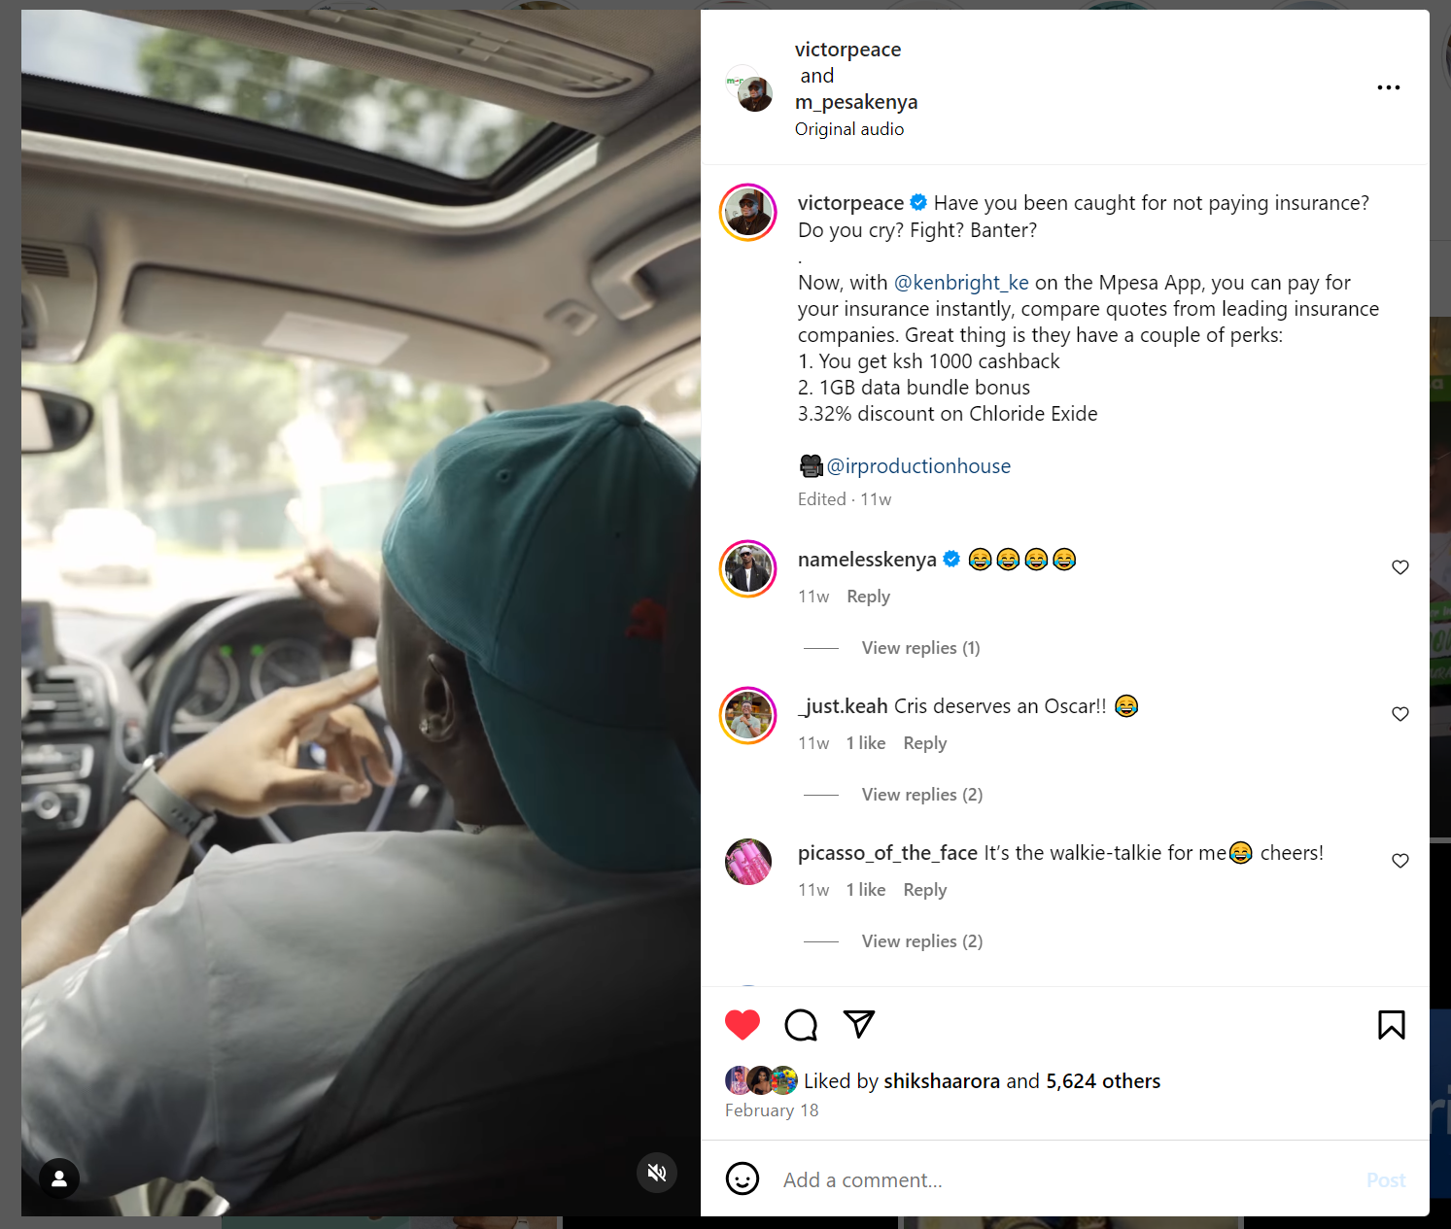

Figure 2: Top performing Instagram Post - February 2024

* 1. The most successful post in the month of February was the reel that featured Victor Peace and Chris Njoki on a collaborative skit showcasing our product (vehicle) on M-PESA App.

# LINKEDIN

* 1. The table below shows the insights recorded on LinkedIn during the period of reporting.

Table 3: LinkedIn Insights - February 2024

|  |  |  |
| --- | --- | --- |
| LINKEDIN  FEBRUARY 2024 | | |
| **KPI** | **Total** | **Percentage** |
| Unique Visitors | 485 | +100.4% |
| Custom button clicks | 2 | -33.;3% |
| Followers new | 391 | +35.3% |
| Content reactions | 631 | +94.8% |
| Reposts | 9 | +80% |
| Comments | 26 | +333.3% |
| Impressions | 22587k | +83% |
| Page Views | 1387 | +103.1% |

* 1. **Unique Visitors:** The page attracted 485 unique visitors during the month, reflecting a significant increase of 100.4%. This suggests that the content on the page is successfully attracting new and diverse audiences.
  2. **Custom Button Clicks:** Custom button clicks experienced a slight decrease of 33.3%, with 2 clicks in total. This suggests for inclusion of hyperlinks on our posts.
  3. **New Followers:** There was a gain of 391 new followers in January, representing a growth rate of 35.3%. This shows that the page is successfully expanding its follower base and increasing its reach.
  4. **Content Reactions:** Content on the page received a total of 349 reactions, indicating a substantial increase of 3.6%. This suggests that the content shared resonates well with the audience, evoking positive responses.
  5. **Reposts:** The number of reposts increased by 80%, with a total of 9 reposts during the month. This demonstrates that the content is not only being consumed but also shared by the audience, extending its reach further.
  6. **Comments:** Comment engagement witnessed a significant surge, increasing by 333.3% with a total of 26 comments. This indicates that the content is sparking discussions and interactions among the audience.
  7. Overall, these insights suggest a positive trend in LinkedIn performance for February 2024, with increased engagement, page views, and new followers.
  8. The content appears to be resonating well with the audience and encouraging active interactions, making it a successful month for the LinkedIn page.
  9. Below is an image of the top performing post on LinkedIn during the reporting period.

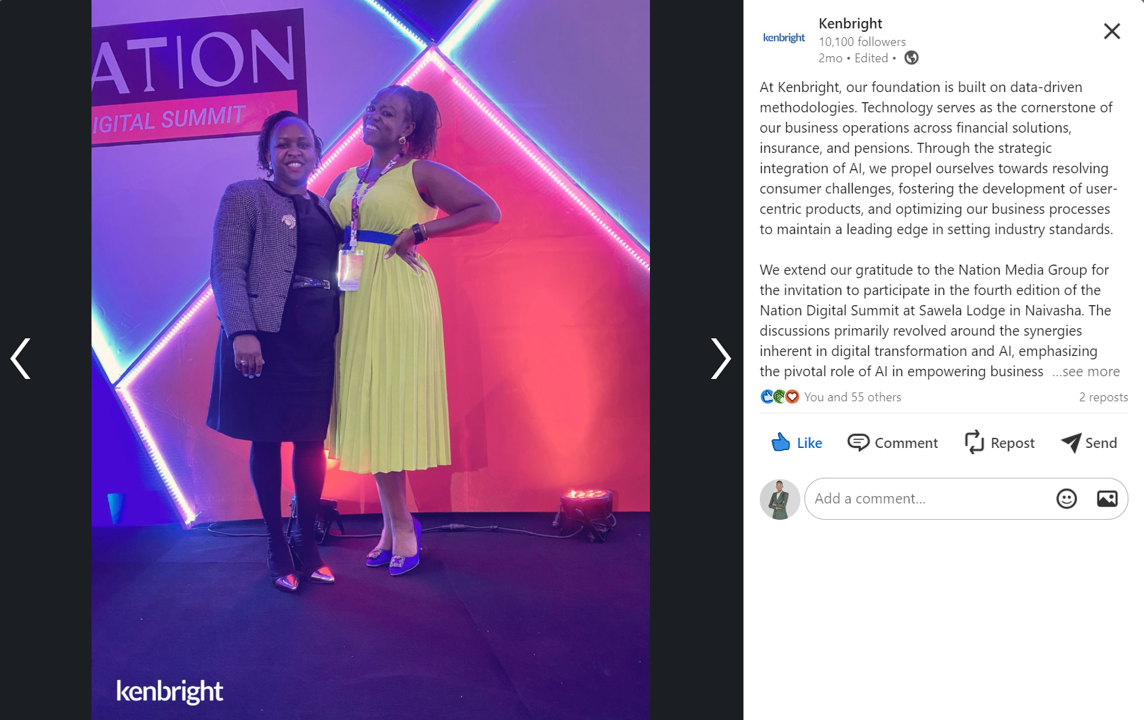

Figure 3: Top performing post on LinkedIn - February 2024

* 1. Notably, the most successful LinkedIn post featured the operations director for Kenbright Holdings MS Wendy Gondi at the National Digital Summit hosted by Nation Media.

.

# FACEBOOK

* 1. The table below shows the insights recorded on Facebook during the period of reporting.

Table 4: Facebook Insights - February 2024

|  |  |
| --- | --- |
| FACEBOOK  FEBRUARY 2024 | |
| **KPI** | **Total** |
| Reach | 2.4k |
| Engagement | 139 |
| Page Likes (new) | 2 |
| New followers | 20 |
| Reactions | 81 |
| Interactions | 183 |
| Shares | 1 |
| Photo views | 30 |
| Page Visits | 449 |

* 1. **Reach:** The reach significantly increased to 2.4k, an increase of **73.7%.** This can be attributed to the social media ad promotion that was done to boost the 1k Third Party Only Motor Insurance.
  2. **Engagement:** While engagement decreased slightly from 146 in January to 139 in February, it still represents a substantial level of interaction with the audience.
  3. **New Page Likes:** We recorded a total of 2 new page likes which is relatively slow and calls for action.
  4. **New Followers:** The growth in new followers was average, where we recorded **20** new followers.
  5. **Reactions Total:** Our reactions for February were relatively higher where we recorded **183** against 121 in January.
  6. **Photo Views**: Photo views saw an increase from 12 in January to 30 in February.
  7. **Link Clicks:** The page did not garner link clicks and thus posing a very crucial area of improvement particularly on the inclusion of clickable hyperlinks on our weekly posts.
  8. In summary, our Facebook page on February was relatively better but still warrants a review on content strategy and optimization.
  9. The image above shows the top performing post on Facebook. It garnered 691 impressions and a reach of 662.

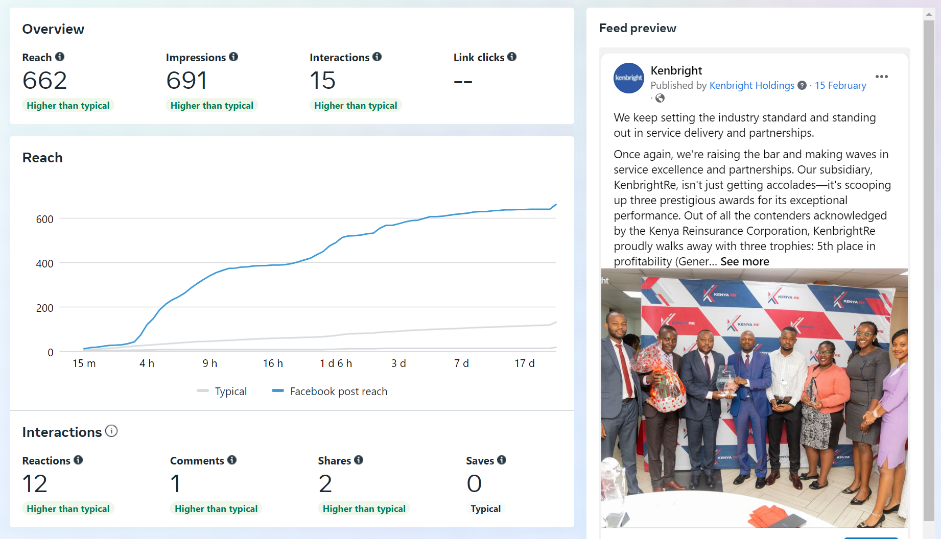

Figure 4: Top performing Facebook Post in February 2024.

* 1. Notably, the most successful organic Facebook post featured our victory when Kenbright Reinsurance Brokers was honored massively by the Kenya Reinsurance Corporation.

# RECOMMENDATIONS

* 1. **Search Engine Optimization (SEO):** Enhance our website and content for search engines to improve organic visibility and achieve higher rankings in search results.
  2. **Google My Business Listing :** Update and improve out product catalogue on Google My business and Google Merchant Centre.
  3. **Influencer Marketing:** We should explore influencer marketing or brand collaborative marketing to boost our social media presence.
  4. **Engaging Content:** Focus on developing and distributing top-tier, relevant, and captivating content that resonates with our target audience. Utilize a mix of text, visuals, videos, and infographics to sustain our audience's interest.